In home page:
1.The icon symbol of PMG is different.
2.In one website there is contact us but in another website there is only contact and beside there is search bar symbol.
3.In first page the background is completely different.
4.The font size of Strategy is Intention. Execution is Reality. Is different in the websites.
5. 
This Is different in website, just we want to exchange both. And
6.In same the box size is some bigger comparing the both website.
7. In picture there is one line, the gap is different above page and that line in both the website.
8.The font size of Our Expertise What We Help With and
As functional consultants, we offer targeted expertise across key business areas to drive tangible results. Is completely different.
9. 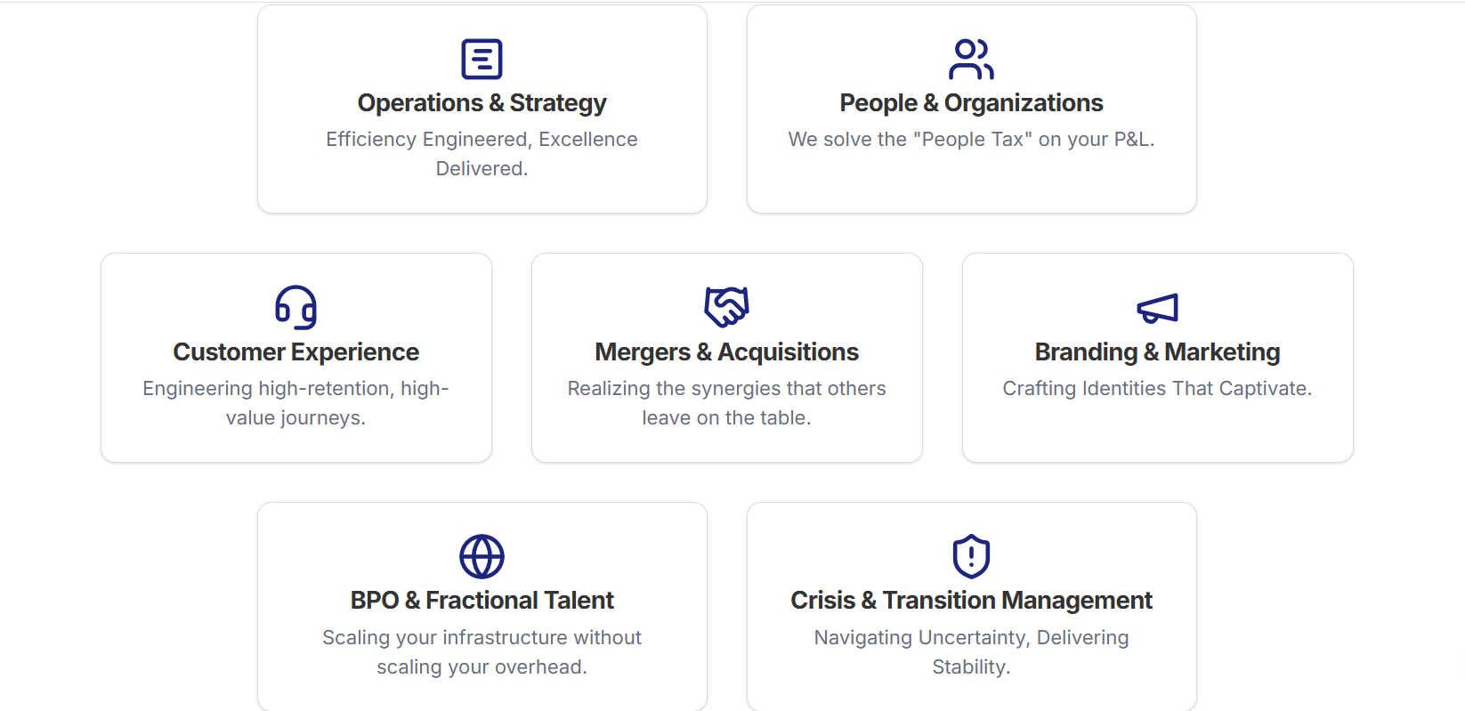In one website there is in boxes type and in another website there is some different.
10.And in next page the font size of Why Partner with PMG?
Because results matter more than reports. We focus on quality first, consistently outperforming the industry. Is different in both the website.
11. 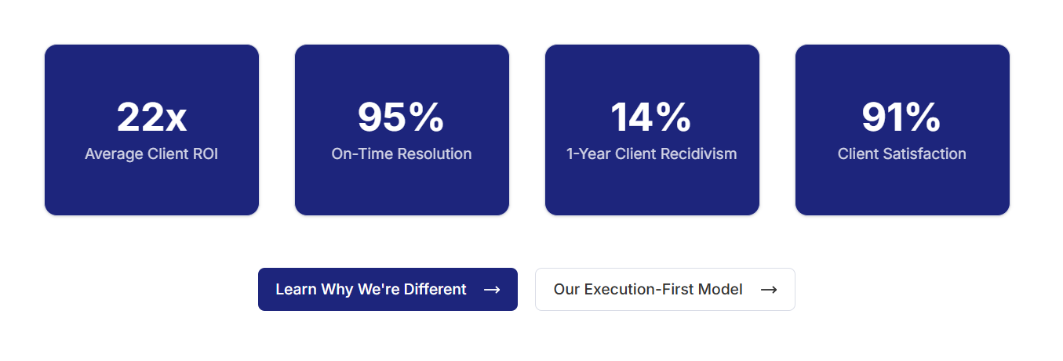This Is completely different, and the last line is not there in one website.
12. Traditional Consulting is Broken
The old model of consulting is failing. We built PMG to be different, focusing on execution and tangible results, not just slide decks and billable hours.
Why We're DifferentUnderstand Our Approach

In this page also the font size is different in both the websites. And the matter below the tittle is in three line and in another webiste it is in two lines.
13. 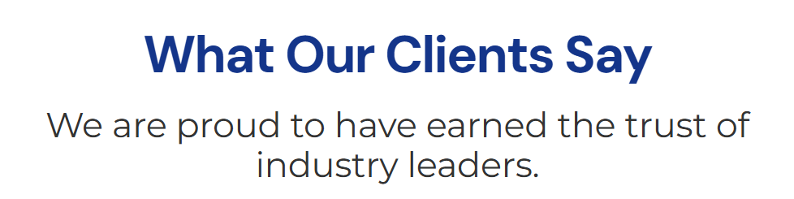In one website the tittle is in black colour and below that 2 lines are there in one line.check that
14. 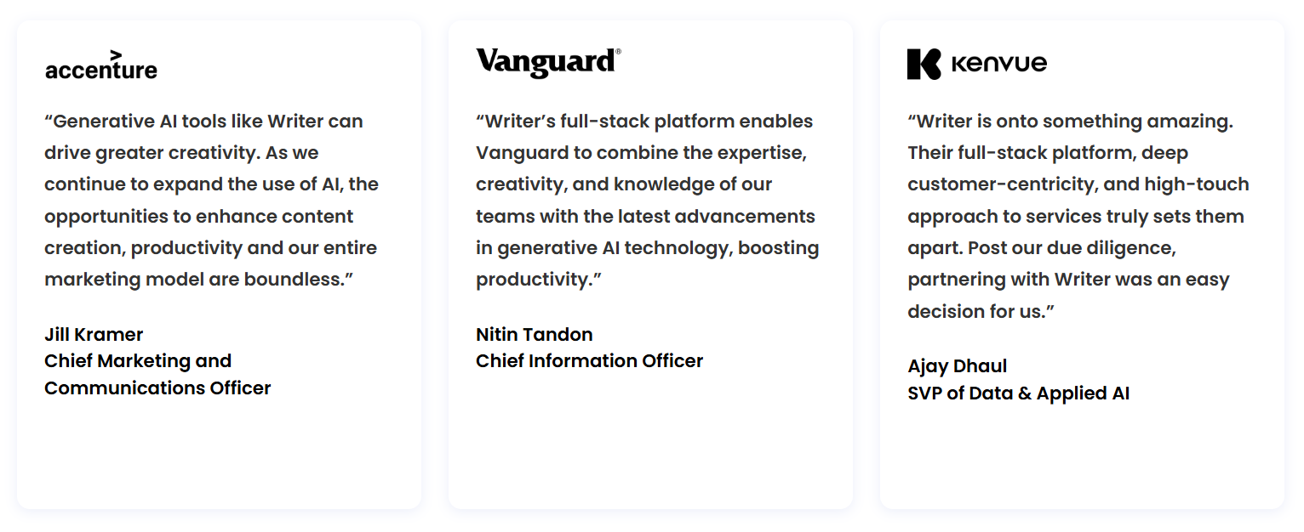this thing is not there in one website.
15. 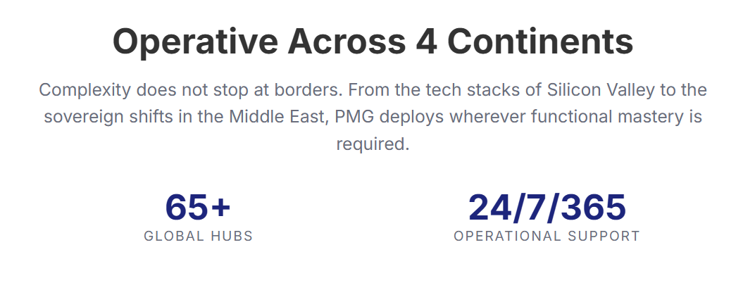The font size is different and the colour of Operative Across 4 Continents is different . And below that should be in the box, check and correct.
16.In below that there is map, in another website there is no map , check that once.
17.In last page the background is completely different and 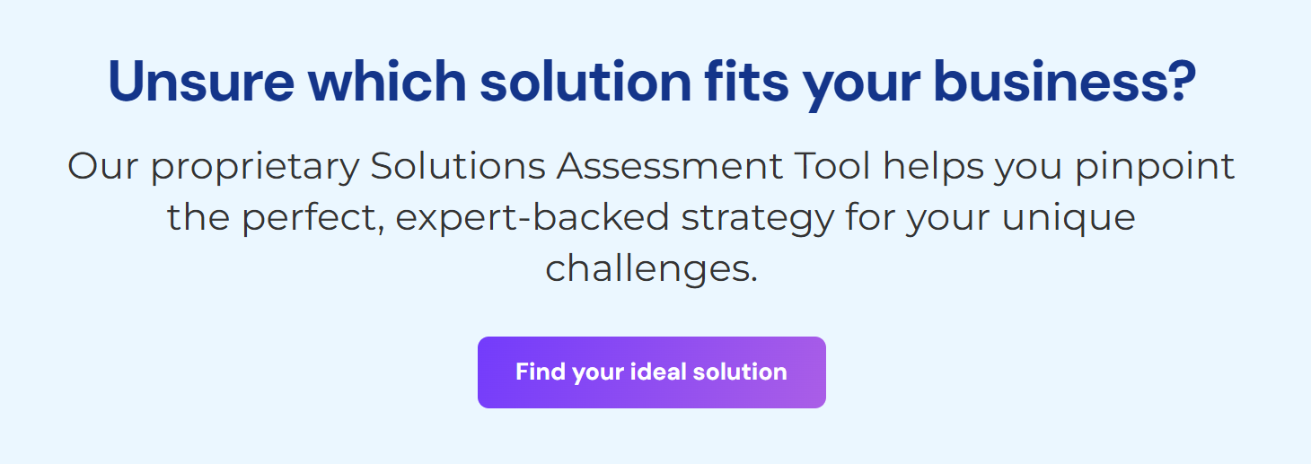this thing is not there in website.
18. 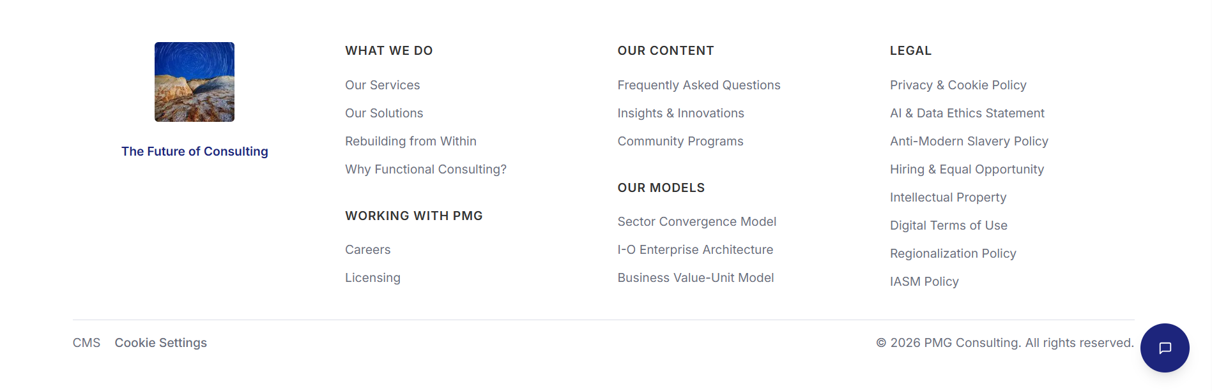The icon is different in this page and the background also different check once this that website. And beside that, the things there is some changes in that check once In the website.

In about page:
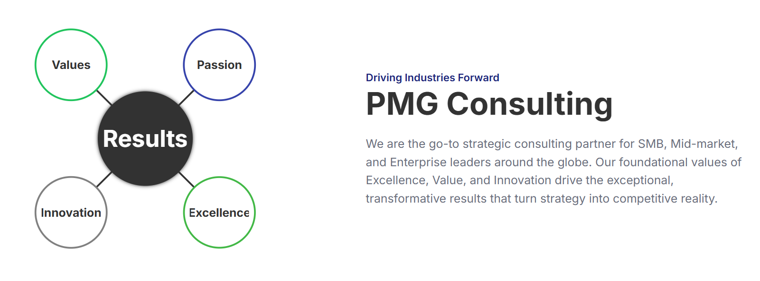1.The diagram should come below that content and the digram is also different change that. And Driving Industries Forward this line should come below PMG CONSULTING.
2. That should be in 2 lines and the colour is different.
3. 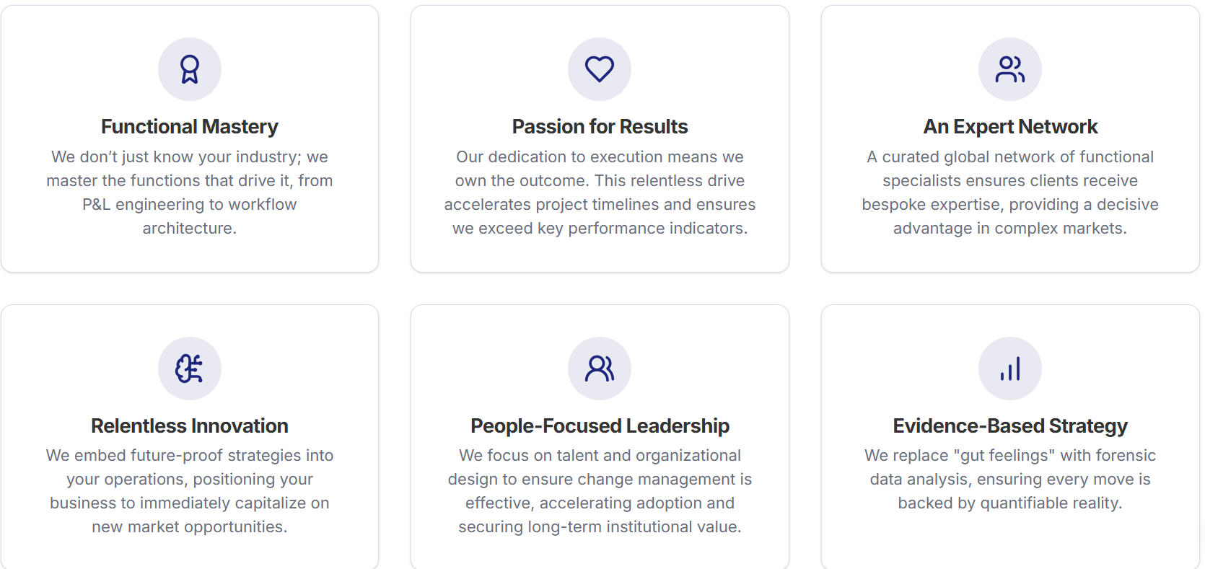
The icons are different as u see in that website and the colour is also different check that.and in that boxes there is some changes.
4. 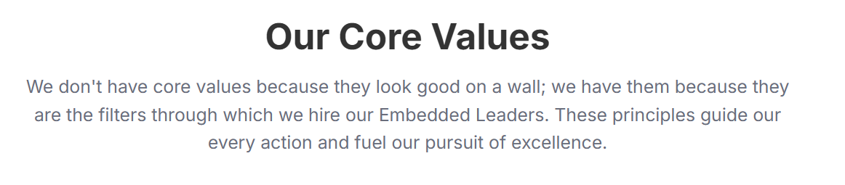the colour of tittle is different and below that the font size is also different.
5. 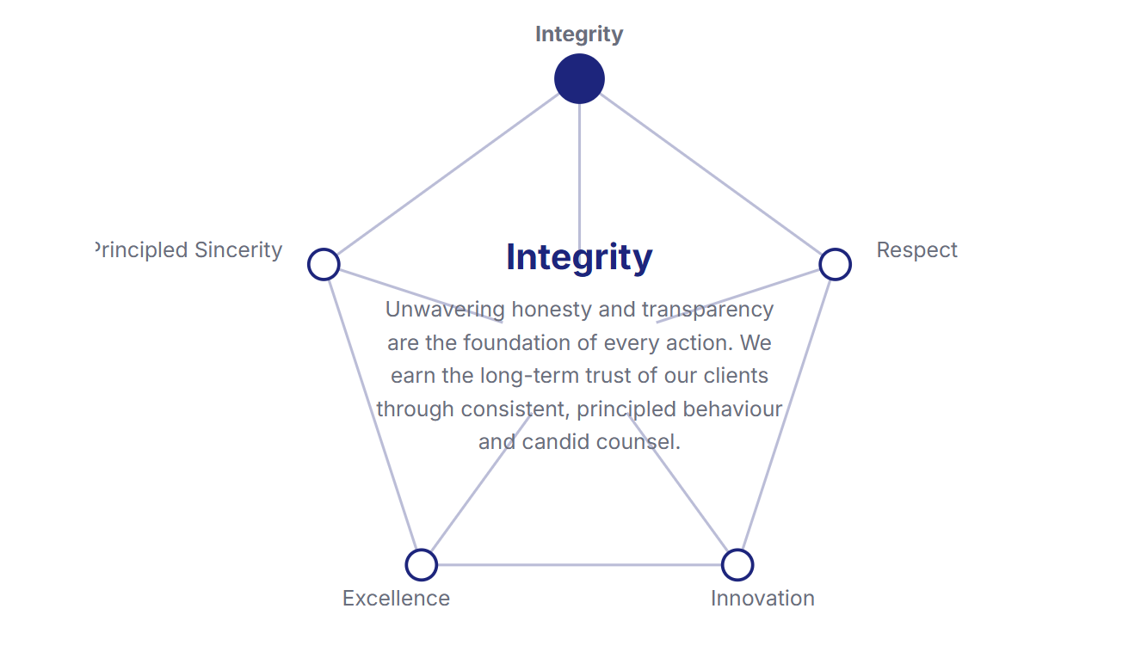inside that picture the integrity topic there are some changes the font size is big and inside that there is no star in that so check that once.
6. 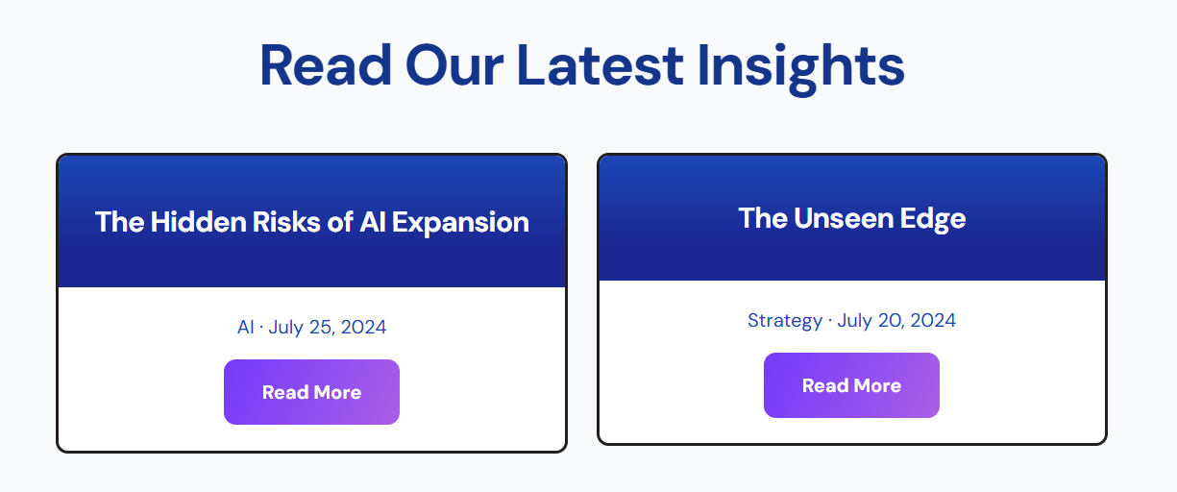below the title the boxes are not there in that website.
7. 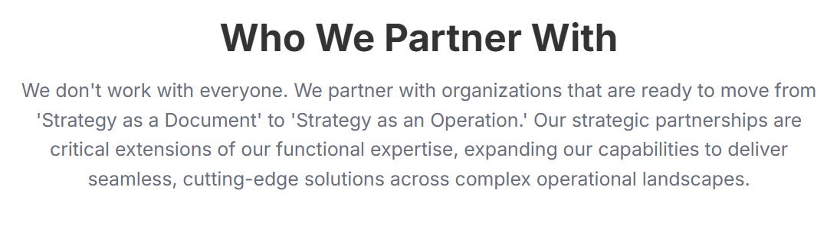the font size is different.
8. 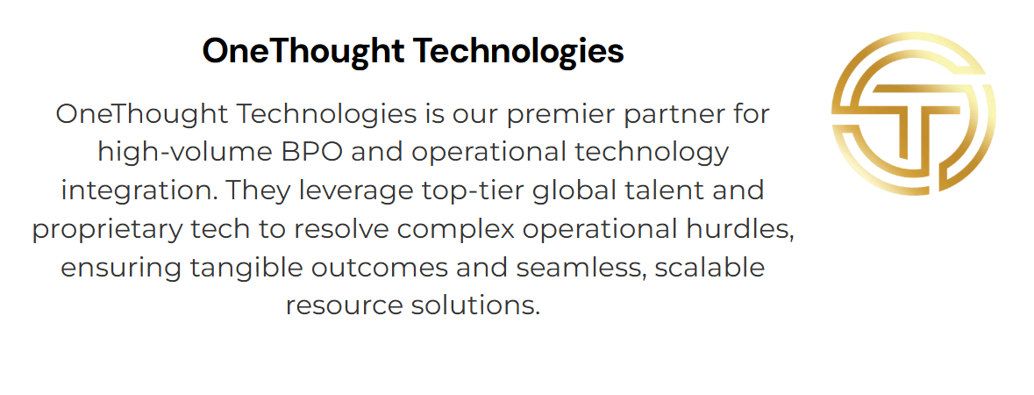in this icon place is different in that website.
9. 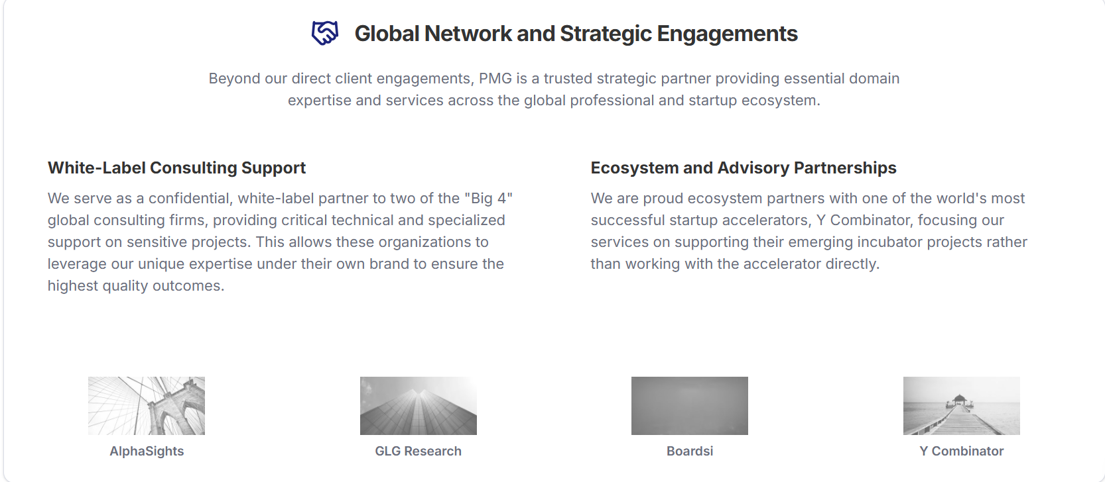in this page the tittle font and the below matter font is different and the pictures below that are completely different check once.
10. 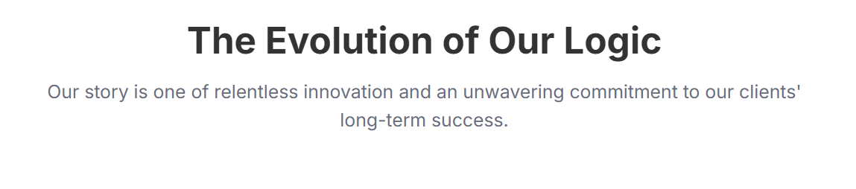the tittle colour is different and below that the things are some different change that.
11. 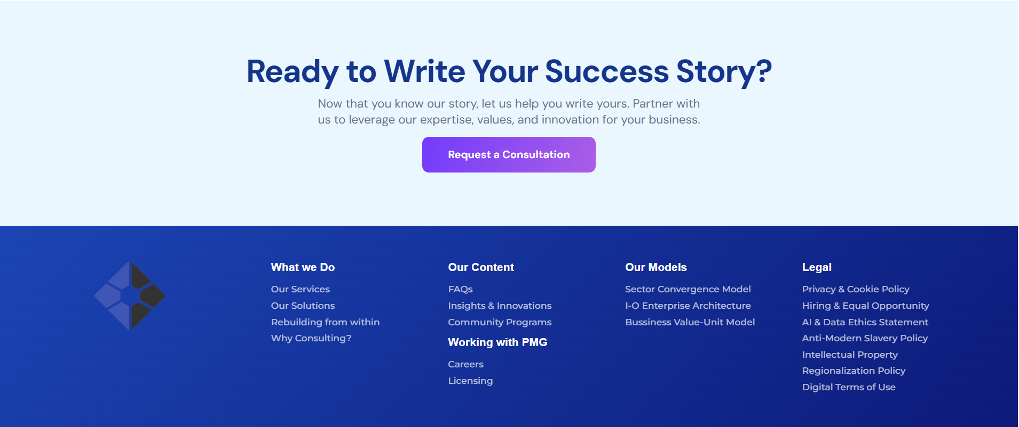the background is different and the icon is different in that page and there is some changes in the content change that compare to the another.

